**First Terminal Examination-2082**

**Class: Nursery Time :- 2 hrs. F.M.:50**

**Sub :Maths (O) P.M.:18**

1. What is your name? [5]
2. How are you? [5]
3. What is your school’s name? [5]
4. Say 1 to 10? [10]
5. Say ! - !) ? [10]
6. What is your class teacher’s name? [5]
7. Read the following numbers ? [5]

**1 2 3 4 5**

9. Identify the pictures. [5]



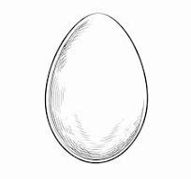



**The End**